The equation of heat conduction in 2D is:

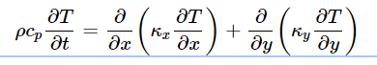

where ρρ is the density, cp is the heat capacity and κ is the thermal conductivity.

If K is constant, in our assumption it is then the equation is



Where α is the thermal Diffusivity. But as we have two plates the equation needed is

1. α = α1 of plate 1 from 0 to L1
2. α = α2 of plate 2 from L1 to L2

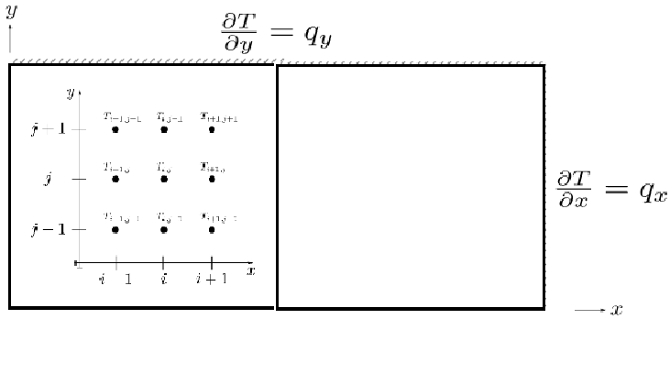

The System is composed of two plates insulated on all four ends with heat freely moving between them. To solve the values at the next step, the heat equation will have to be discretized using

1. forward time difference
2. central space difference